

**Software Engineering 2**

**Group Project**

**Assignment (1) & (2)**

**Submitted by:**

Aly Mohamed Aly

Marina Gamal Ibrahim

Moussa Mohsen Moureed

Mohammed Said

**Project:**

-Student Attendance System by Barcode Scan

-The project is a system that takes down students’ attendance using barcode. Every student is provided with a card containing a unique barcode. Each barcode represents a unique id of students. Students just have to scan their cards using barcode scanner and the system notes down their attendance as per dates. System then stores all the students’ attendance records and generates defaulter list. It also generates an overall report in excel sheet for admin. Such kind of application is very useful in school as well as in college for daily attendance.

-Barcode scanner

**Functional requirements:**

-barcode scanner in each lecture hall

-display screen

-to display full student information and current course in this hall to avoid errors in the system

-scanner connected to the database of the university with information about schedules

-visual response indicating a successful/failed operation

-does not allow multiple entries for the same lecture

-the scanner must register an entry and exit to credit the attendance to the student

(if the student has more than one lecture in the same hall, only one entry and one exit are required to credit the attendance for all the lectures)

**Non-functional requirements**:

-requires very fast response time to avoid long queues (maximum 1.5 sec)

-backup system for the database

-contact number in case the scanner has malfunctioned

-easy to use interface

**Viewpoint: Students**

**Services:**

* Limited online access to the system to see their attendance record.
* The system scans the unique barcode on each card using a scanner and the system then notes down their attendance.
* Students should be able to print their document as a proof through the online system site.
* Notifications via email.

**Data provided:**

* Student’s name
* Picture
* ID
* course name
* Doctor’s name
* Hall number

**Events:**

* The student scans his/her college ID with the barcode through a scanner available in each lecture hall. The scanner connected to a small screen displays the required data mentioned above and a visual response indicating success or failure in the system.
* Each student is provided with a username and a password to access the system online. Inside, they can view their attendance record for each course. They are notified via email if they are to exceed the limit of absence. Students can choose to print a document of their attendance record in a certain course to be provided as a proof in case of errors in the system.

**Viewpoint: Lecturer**

**Services:**

* Access to database of the system to be able to search for students’ details.
* See attendance records for each student.
* Do some calculations on the data.
* Retain a copy of the records.
* Notifications via email.

**Data provided:**

* Student’s name
* ID
* Picture
* Semester
* Attendance records
* Grades
* Number of students in the course

**Events:**

* + Lecturer is provided with a username and a password to access the system online. Inside, he/she can select from different options including viewing attendance records for each student. The ability to contact a certain student or if the student exceeds their absence limit, they are alerted. In case, a student drops or withdraws the course, the lecturer is also notified.
* Lecturers can receive a copy of the records to use during preparing students’ coursework marks.

**Viewpoint: System management**

**Services:**

* Add new students’ information to the database.
* Remove graduated students from the database.
* Display number of students using the system.
* Find a certain student.

**Data provided:**

* Student’s name
* Program
* ID
* Date of birth
* Courses
* Registered courses for each student
* Schedules of college programs
* Courses in each lecture hall
* Contact details for each student and lecturer

**Events:**

* System management staff can access most of the system and is given permission to edit data such as adding new students or removing students who graduated or withdrew a course. The staff is to be notified if an error occurs in a certain scanner or in the online interface.

**Non- Functional constraints:**

* High efficiency.
* Easy interface.
* Available all the time.
* If the system is down it should recover in less than 1 minute.
* Fast response time (2 seconds).
* There should be a backup system.
* Secured.

**Risks:**

-System malfunction which results in wrong barcode scanning results.

-Technology risk where the system cannot process that much attendance operations due to a large number of students which can result in errors in the database such as ungiven attendance marks or wrong lecture loaded from database.

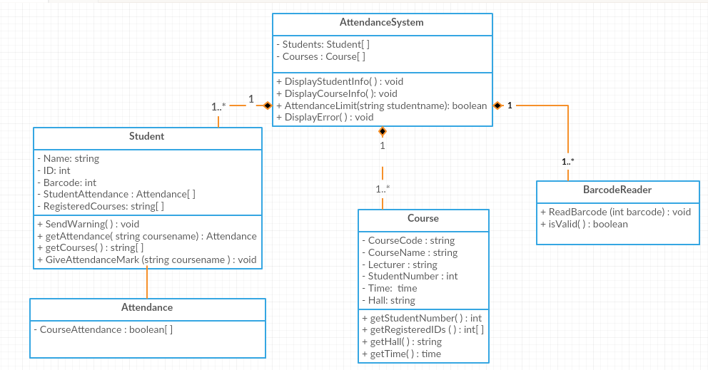**Class Diagram:**

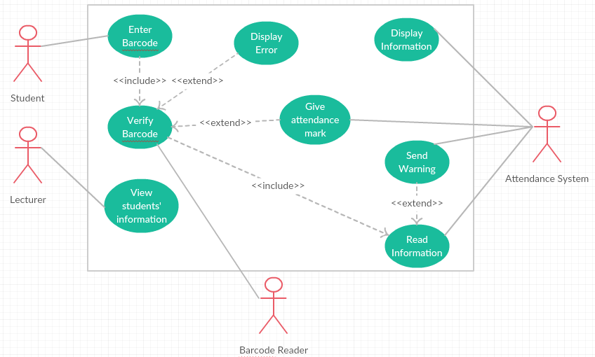**Use Case Diagram:**

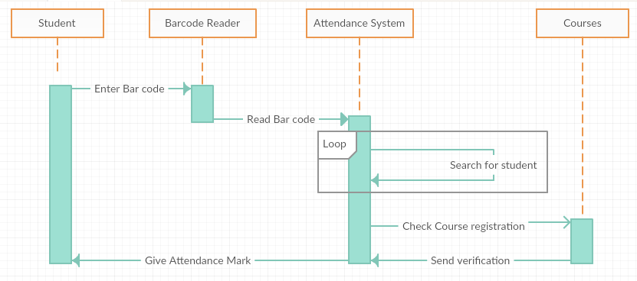**Sequence Diagram:**

